|  |  |  |
| --- | --- | --- |
| Checkpoint III | Checkpoint III: Visualization Sketch | |
| Group: | G18 |
| Date: | 2023/10/08 |
|  |  |

# Overview

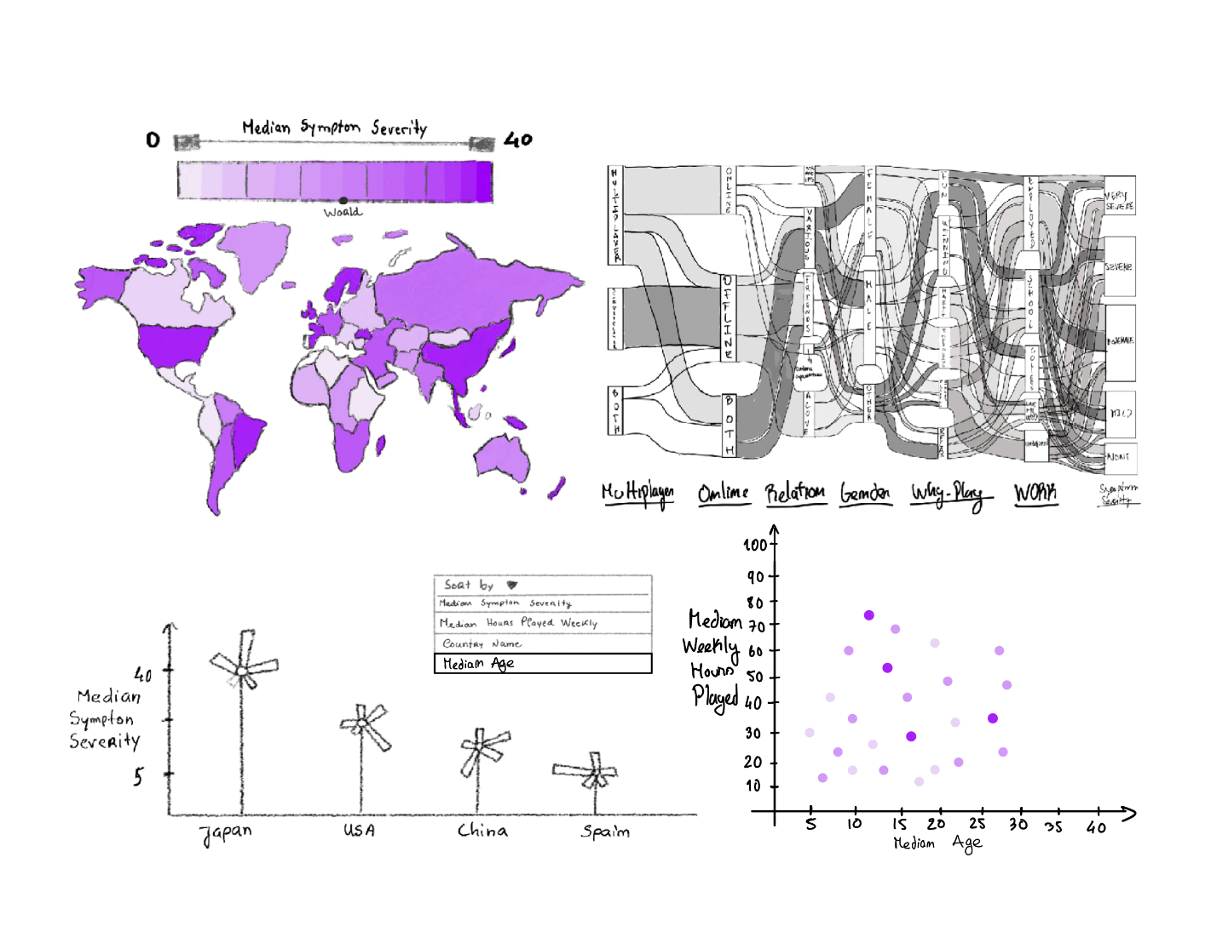

# Visual Encoding

On the choropleth map, mark country is encoded by shape and location on the map using equirectangular projection, and its gamer’s median social phobia inventory test result (median SPIN_T) is encoded by channel color luminance (purple’s, in this case). Symptom severity according to this result is perpetually represented. World median SPIN_T is encoded by a dot on the color scale.

In the sankey graph, player attributes (regarding playstyle, demographics, and play motivation) are encoded by mark “rectangle”, and the percentage of their values’ occurrence is encoded by channel rectangle length (symptom severity is encoded in the same way, for better comparison). Simultaneous occurrence of traits is encoded by flow, and we can drag the corresponding attributes (multiplayer, online, …) to switch their order and identify flow between different values. It is relevant to mention that all attribute values (e.g.: genders male and female) are to have their names under their respective rectangle and that for each attribute, its possible values are meant to be ordered by percentage of occurrence; there was simply no time to alter the sketches in time to fix these oversights. Mark country is encoded on the scatterplot via circle, median age via circle-xPos, median hours played by yPos, and median SPIN_T by color luminance (to match the Vis); we chose not to represent number of residents who answered via area since we already use median and the larger number of items (and items from English-speaking countries) would make circle size obfuscate data and confuse viewers in a Vis where we want to highlight differences between countries.

In the custom lollipop & radial column sparkline chart, countries are encoded by circles, which can be ordered according to a few features via drop-down. Channel circle-yPos encodes the country’s median social phobia inventory. Symptom severity category is encoded in a bar, its value is encoded by angle/static position around the circles; bar height is used to represent the percentage of the population with the corresponding symptom severity. All countries are represented.

Any given number of countries (choropleth, lollipop) may be selected; range (e.g.: hours played) or type (e.g.: multiplayer gamers) of values analyzed may be specified in the various encodings. Both of these will filter both it and other encodings to match the gamers that match the specifications. Hovering over a country, symptom severity category, or gamer trait (sankey) highlights it on the rest of the encodings if feasible, and clicking on it will trigger filtering. Sankey filtering is done with AND for values of different attributes, and OR for values of the same attribute. Tooltips are present for countries & symptom severity, detailing median SPIN result per question.

# Answering the Questions

Q: Do people who play online with friends tend to experience less social phobia than people who do so with strangers, in most countries?

A (encodings separate for easier understanding):

“(1) I select the player traits I wish to see: “Online”, “Multiplayer”, and “Friends”, on the sankey. I’ll also drag the symptom severity section until it is after the “Relation” one, so I can see the global symptom severity according to “Relation” better. I then look at the changes on the countries (currently ordered by median level of SPIN_T) in the lollipop-chart, and at the flow toward the “Relation” values on the sankey.”

“(2) I deselect “Friends” and select “Strangers”. I note the difference in the lollipop circle yPos, bar lengths, and new country order, plus sankey flow, and conclude there’s actually not much difference globally - but there certainly is for a few specific countries.”

|  |  |
| --- | --- |
| **Part 1 - “Friends”** | **Part 2 - “Strangers”** |
| The colors of the map and scatterplot change as well as the severity of the symptoms, the age range changes as well, and the range of hours played weekly. | |
|  |  |
|  |  |
| When the multiplayer mode, online, and friends options are selected, the Sankey diagram changes, displaying only the flow of these selected attributes. Dragging the symptom severity column also causes the chart to change to associate the correct connections, enabling a better comparison. | |
|  |  |
| The flowers change, representing in descending order the countries that, with the selected attributes in the Sankey chart, exhibit a higher median SPIN_T result. | |
|  |  |

Q: How does the prevalence of social phobia ailments vary throughout countries across different player ages?

A: By selecting a specific section on the age scale on the scatterplot, the color luminance of the countries’ marks changes, as does the order of the countries in the custom chart (when ordered by median SPIN_T), allowing us to identify which countries have a higher median symptom severity and its variation per country and even continent, identifying patterns if there are any.

Q: Environments like school and work are used to socialize. Do players who are unemployed play online multiplayer games with strangers more often than those who are not?

A: Order the custom idiom by hours played. Choose the attributes of "unemployed," "multiplayer," and "strangers" in the Sankey chart, and then observe the updated range of hours per week played, as well as the difference in country order in the custom idiom. Next, select other attributes from the "work" section, de-select "unemployed," and compare the range of hours per week, as well as the difference in country order in the custom idiom.

Q: Given a similar number of hours played, do victory-motivated players have less social phobia incidence than fun-motivated players?

A: Establish the interval of hours played for which we want to compare victory minded players with those that play for fun on the scale (e.g.: 20-30) by selecting that range on the scatterplot’s y-axis. Order the sankey plot so that “why play” comes before the symptoms; select both players who play for fun and players who play for winning’s sake; see how they distribute across the 5 levels of symptom severity. Then, select “Fun” and “Winning” separately and see how on other idioms each one’s distribution changes across countries as well.

Q: How do levels of social phobia change between genders, for each playing style?

A: In the Sankey chart, choose the gender you want to visualize and select the playstyle type: multiplayer online, multiplayer offline, or singleplayer. Then, compare these values.